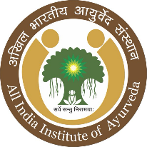
अखिल भारतीय आयुर्वेद संस्थान, गोवा
All INDIA INSTITUTE OF AYURVEDA (AIIA), GOA
(आयुष मंत्रालय, भारत सरकार के अंतर्गत स्वयात्त संस्थान)
(An Autonomous Organization under the Ministry of AYUSH, Govt. of India)

Academic Brochure
2023-2024

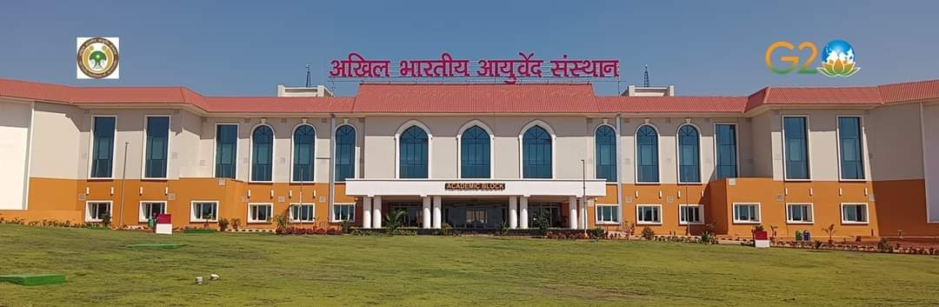

PANCHAKARMA TECHNICIAN COURSE

Last date for receiving Applications
15th April 2023

All India Institute of Ayurveda (AIIA), Goa
All India Institute of Ayurved, Goa is a satellite centre of All India Institute of Ayurveda, new delhi which is an apex institute of Ayurveda. It aims at bringing synergy between traditional wisdom of Ayurveda along with modern tools and technology.
The institute offers under graduate and diploma courses in various disciplines of Ayurveda. It focuses on setting highest standards of education, research, patient care and also to function as a Centre for medical value tourism.
It is having a 250-bed hospital for facilitating patient care and clinical research.

PANCHAKARMA TECHNICIANCOURSE
What is Panchakarma?
Ayurveda is one of the most popular and accepted traditional medicine systems across the globe. Panchakarma being the most integral and important part of Ayurveda Medicine is time tested and evidence based. The popularity of Ayurveda has increased in recent times by the wide acceptance on efficacy of Panchakarma Therapy.
Panchakarma therapy being a bio detoxifying methodology requires systematic technical assistance for the smooth conduction of procedures. Panchakarma procedures are utilized to cleanse the body in a deeper level along with different external therapies. At All India Institute of Ayurveda, a unique and intense course has been designed, which is one of its kind in the country.
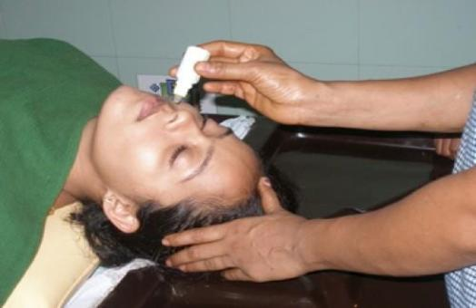

The course offers
This course helps one who learns the same to be technically trained and confident along with a deeper insight to the healing science of Ayurveda and its principles. At the same time the course even provides an ultimate opportunity for the ones who undergo, to place themselves globally in a very high demanding job in Ayurvedic hospitals, Panchakarma centers, Health resorts, wellness centers etc. The demand for skilled Panchakarma technicians are on high-rise as the acceptance of Ayurveda is widely spreading across the globe.

Advantages with AIIA
The candidate gets to learn from the most experienced and best faculty along with the most premier infrastructure in the country. Every candidate undergoing the course will be confident and trained a class apart from the rest. After due completion of the course the candidate will be awarded the certificate from AIIA, the premier institution of the country providing a higher
reputation and acceptance at global platform.

Admission in Panchakarma Technician Course
Eligibility for Admission
- 10 +2 Passed out any recognized school by state board/ CBSE/ICSE or any other recognized board by Govt. of India.

Age Limit
- 16 -35Years

Health status
- The candidate must be physically fit along with good physical and mental endurance.

Duration
- One Year

Selection Procedure
- Based On merit, counseling / entrance exam.

Counseling and Medical
- Provisionally selected candidates for counseling will have to appear at the institute on the specified date and time when so called for at their own expenses.
- Candidate will be medically examined by a Medical Board of the institute, to certify their medical fitness.

Medium of Instruction
- English and Hindi

Seats

- 10 students per batch

Hostel facility
  - Not available

GENERAL INFORMATION AND CONDITIONS

Applicants are advised to read all instructions carefully before sending their applications

- All applicants must fulfill the essential requirements of the course and other conditions stipulated in the advertisement as on the last date of receipt of the applications (15th April 2023). They are advised to satisfy themselves before applying that they possess essential criteria laid down. Candidates waiting for their
+12 result may also apply, provisionally. Such candidates must pass qualifying examination on or before the date of counseling.

- If any document/Certificate furnished in a language other than Hindi or English, a transcript in Hindi/English of the same duly attested by a Gazetted Officer or Notary is to be submitted.

- The date for determining the age and qualification will be the closing date prescribed for receipt of application.

- Reservation status will be applicable as per central government norms.

- Institute reserves the right to make any amendment, cancellation and changes in this advertisement in whole or as per part without assigning any reason thereof.

- Any corrigendum/order regarding this advertisement will be issued on the website only. Candidates are advised to remain in touch with the website for this purpose. No separate corrigendum etc. will be published in Newspaper.

- Applicants will be fully responsible for the accuracy of the information they furnish. Any information furnished by the candidate if found wrong at any stage will result in his/her disqualification and/or dismissed from the service at any stage and No correspondence will be entertained at all.

- The entrance exam/ interview/call letter, if shortlisted shall be sent by speed/registered post and e-mail. However, the Institute shall not be responsible for any postal delay or lapse, whatsoever.

- No Correspondence or personal inquiries shall be entertained.

- Candidate would have 15 days’ time for withdrawal of candidature after admission, after this period candidate would have to pay full one year fee if withdraw from the course before completion.

- In case of any dispute on this issue, the jurisdiction will be in Goa.

- Canvassing in any form will be treated as a disqualification

- The decision of the Director, All India Institute of Ayurveda (AIIA) will be final in this regard.

Application Fee (by Bank Demand Draft (DD) only):

All interested applicant has to attach a Demand Draft for an amount of Rs.350/ (General &OBC), Rs.150 (SC & ST Candidates)- along with application form.
Applications not supported by the appropriate copy of claimed certificate for the reservation category (under Application Fee relaxation) shall be considered, as General/unreserved and fee amount will be paid accordingly.
Application fee: Bank Demand Draft(DD) in favor of

“Director, All India Institute of Ayurveda” payable at New Delhi.
On backside of DD, candidate must mention- Candidate name, category and course applied for.
Application Fee once paid will not be refunded under any circumstances.

How to apply:

Candidates are required to apply in the prescribed format downloaded from website or neatly typed on A4 size paper on one side as per the format available on the website http://www.aiia.gov.in as per the prescribed Performa of Applications form. Institute will not consider any another format or application Performa.

Application completed in all respect enclosing self-attested copies of all certificates, mark sheets, testimonials in support of age, educational qualifications, caste/community in prescribed format by Govt. of India, the supporting documents

along with application should be sent in an envelope superscripted “APPLICATION FOR PANCHAKARMA T E C H N I C I A N COURSE 2022-23” by registered/Speed-
Post on or before the last date (15th April 2023), to:

The Dean (Administrative and academics),
All India Institute of Ayurveda (AIIA), Village-Dhargal, Taluka - Pernem, Mopa Airport Road, Goa- 403513

Candidate must sign in the application form.

Invalid Applications:
Candidates are advised to read all instructions carefully before sending their applications otherwise their applications are likely to be rejected on one or more of the following reasons in terms of the notifications.
- Applications received after the closing date
- Applications not in prescribed format
- Candidates not having the required qualifications
- Applications without latest photo not being pasted in the provided space
- Applications without declaration
- Application without signature
- Applications without supporting documents
- Applications, which are incomplete/illegible in any manner
- Applications without the prescribed Application Fee (as applicable)
- Application on another format not prescribed by AIIA

Last Date of receiving application:

The last date for receiving completed Application – 15th April 2023.

In case the last date and receipt of application is declared holiday the date of receipt of the application will be considered as next working day.

FEE STRUCTURE FOR THE COURSE

Course fee – Indian Nationals (In Indian Rupees)
Admission Fee | Rs10000.00
Tuition fee per month | Rs1000.00
Caution Deposit (Refundable) | Rs 5000.00
Total amount to be deposited at the time of admission- Rs 18,000/- (including tuition fee of First Quarter).

Course fee – Foreign Nationals (In US dollars)
Admission fee | $250.00
Tuition fee per month | $250.00
Caution Deposit (Refundable) | $250.00
SAARC AND BIMESTAC COUNTRIES | FEE STRUCTURE SAME AS INDIAN NATIONAL
Total amount to be deposited at the time of admission- US $1250 (including tuition fee of First Quarter).

Ayurveda emphasizes the relevance of skilled technician along with doctor, medicine and Patient as a necessary pillar of successful treatment

Charaka Samhita

अखिल भारतीय आयुर्वेद संस्थान, गोवा
All INDIA INSTITUTE OF AYURVEDA (AIIA), GOA
(आयुष मंत्रालय, भारत सरकार के अंतर्गत स्वयात्त संस्थान)

APPLICATION FORM
(For Panchakarma Technician Course)

Name of the course:

Advertisement No:

Category applied for:

(Affix one self-attested recent passport size Photograph & an extra along with application)

Details of fee paid Amount(Rs.): Bank DD No. Dated:

- Name in full :
(CAPITAL letters)

- Father’s /Husband’s Name:

- Address: (CAPITAL letters)

- Present address (for correspondence, with phone/mobile No. &E-mail)-

Email Id: Mobile No:

- Permanent home address-

- Date of birth: dd mm yyyy (in words)

Age (as on closing date of application according to Matriculation Certificate)

- Nationality (Enclose Gov I.D) : 6. Sex: Male Female

7.(a)Mother Tongue :

(b) Other language(s) which the applicant can speak read and write fluently:

8.Whether belongs to SC/ST/OBC/PWD
(in support, please enclose a certificate from authorized Issuing Officer)

9.Examinations passed (Please enclose attested copy of each certificate & mark-sheet):
Examination passed | Name of the Board/ University | Percentage of Marks | Distinction/Rank, if any
10th/Secondary/Any equivalent(name)
12th/Sr.Secondary/Any equivalent (name)

10. Additional information, if any which you would like to mention in support of your suitability for selection:

_
(Enclose separate sheet, if the space is insufficient in any column)

11. DECLARATION

I affirm that information given in this application is true and correct. I also fully understand that if at any stage it is discovered that any attempt has been made by me to willfully conceal or misrepresent the facts, my candidature may be summarily rejected or terminated.

Place: Signature of the candidate

Date:-

(Name in CAPITAL letters)

Annexure

Check-list

  - Bank Demand Draft (Application Fee)

  - All details from column 1 -10 duly filled clearly

  - Point number 4 – attached proof of date of birth

  - Point number 5 – attached government I.D

  - Point number 7 – attached required document

  - Point number 8 – attached attested marks list and certificate

  - Point number 9 – attached required document, if any

  - Two Recent passport size photograph (same as on application)

  - Copy of conduct certificate from the last attended institution

