File no. Z-50/104/2022-AIIA Date 3.10.22
REPORT OF AIIA PARTICIPATION IN CELEBRATION OF AYURVEDA AHARA(GRAIN/MILLETS/RULES) UNDER
THE AYURVEDA DAY 2022
(26th September- 2nd October 2022)
As per directions of Ministry of Ayush, All India Institute of Ayurveda celebrate the Ahara Week during 30th September- 2nd October 2022. The theme for the displays was “AYURVEDA EVERYDAY AYURVEDA EVERYWHERE". The
area designated showcasing the strengths of Ayurveda.
Department of SWASTHVRITTA &YOGA were planned many activities to adopt the healthy lifestyle and Diet .

Day 1 (26.09.22)
Activities: Awareness Lecture+ Quiz
Topic of lecture: Role of condiments in rainy season to boost immunity by Dr. Sapna.
Two prize (packet of ragi fingers) were given to patient ( lovely gupta ,18 yrs and Krishnan KR,29 yrs)
Written Feedbacks were also taken from some patient who attend the awareness lecture.

Beneficiaries: total 200-250 patients

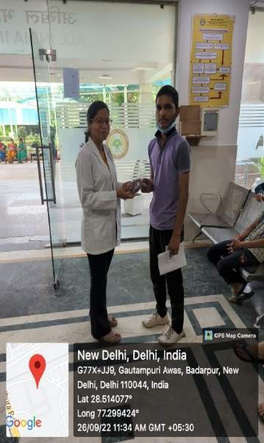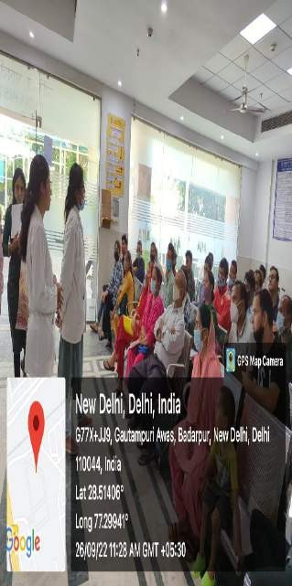

PRIZE TO THE WINNER AWARENESS LECTURE Day 2 (27.09.22)
Activities: Awareness Lecture+ Quiz
Topic of Awareness lecture: Choice of food for monsoon by Dr Neeraj Suryavanshi.
Two prize (packet of ragi fingers) were given to patient (ashish nirmal jain,36 yrs and Kamal raj ,30 yrs)
Written Feedbacks were also taken from some patient who attend the awareness lecture.

Beneficiaries: total 2000 patient attended the awareness lecture,
Guest lecture : Dr.Pratima Narayan Shashtri
Topic of Guest lecture: nutritional significance of food carbohydrates.
Beneficiaries: 35 scholars

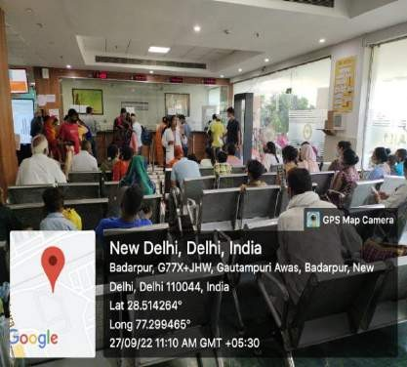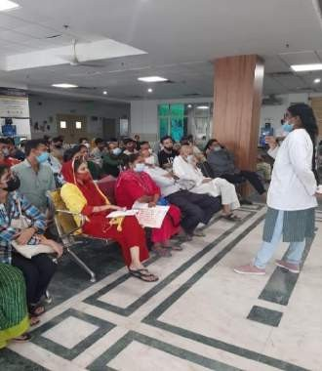

AWARENESS LECTURE
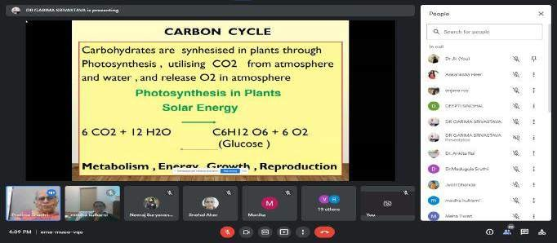
GUEST LECTURE OF DR. SHASTRI

Day 3 (28.09.22)
Activities: Awareness Lecture+ Quiz
Topic of Awareness lecture: Calcium and vit. D and its importance by Dr. Sonia.
Two prize (packet of ragi fingers) were given to patient (Bano,40 yrs and Sonu Sharma ,30 yrs)
Beneficiaries: total 250 patient were attend the awareness lecture.
Ayush ahara stall: Timing: at 11 Am in patient waiting area, At 3 PM ground floor, academic block.

Recipes in stall: Kodo Upma, Ragi Butter Milk
Beneficiaries: total 300 patient approx. Tasted the recipes
200 faculities scholars and staff of AIIA also tasted the receipes.
Written Feedbacks were also taken from some patient who attend the awareness lecture and stall.
IEC materials were also distributed.

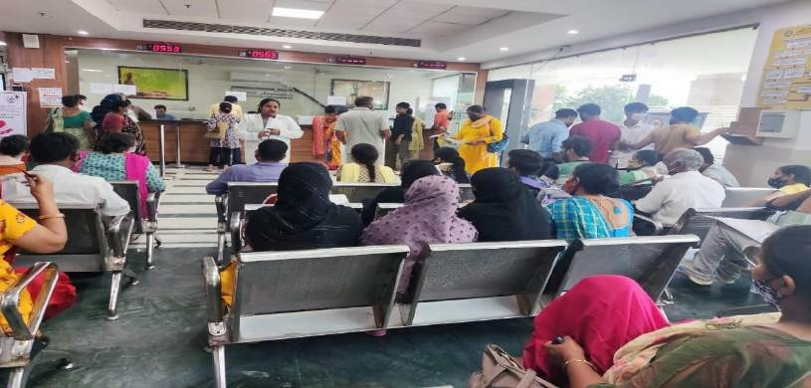

AWARENESS LECTURE

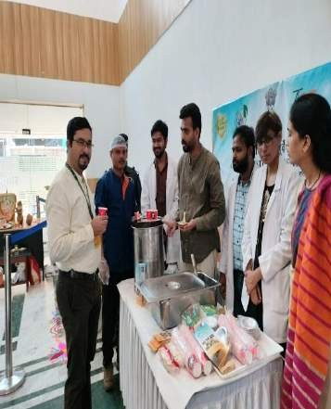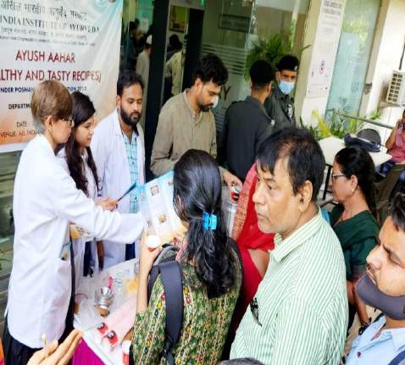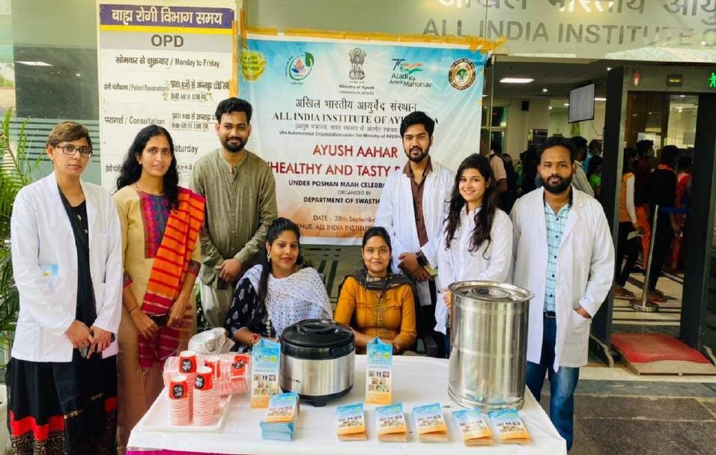

AYUSH AHARA STALL

Activities: Awareness Lecture+ Quiz
Topic of lecture: Food combination by DrNeeraj .

Two prize (packet of ragi fingers) were given to patient (sumita,52 yrs and Munesh,35 yrs)
Beneficiaries: total 200 patient attended the lecture.

Written Feedbacks were also taken from some patient who attend the lecture .
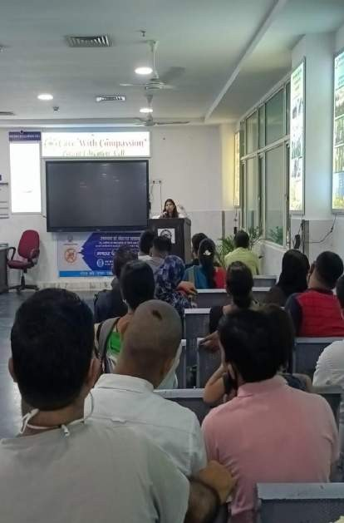
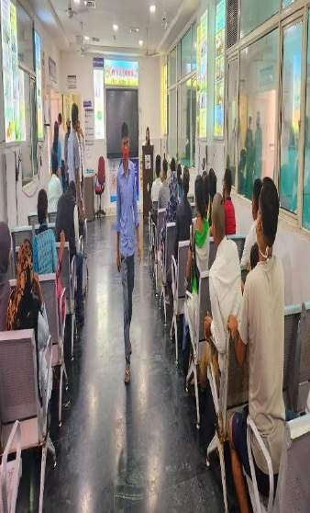

AWARENESS LECTURE

Day 5 (30.09.22)
Activities: Awareness Lecture+ Quiz +
Topic of Awareness lecture: waterborne disease by Dr Mitanjali.
Two prize (packet of ragi fingers) were given to patient (bharti ,40 yrs and Kamlesh ,30 yrs
Beneficiaries: total 2000 patient attended the awareness lecture.
Written Feedbacks were also taken from some patient who attend the awareness lecture.
Guest lecture by Dr. B. Dinesh
Topic of Guest lecture: Ayuceuticals / Herbal / Nutraceutical –
Reverse Pharmacology.
Beneficiaries: total 30 scholars were attend the lecture.
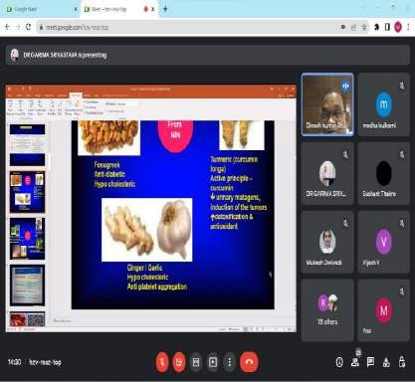
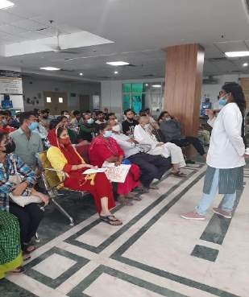

GUEST LECTURE AWARENESS LECTURE

Day 6 (1.10.22)
Activities: Awareness Lecture+ Quiz
Topic of Awareness lecture: storage of food by Dr.Keshav Munde
Two prize (packet of ragi fingers) were given to patient (afroz,19 yrs and Ishaan
,40 yrs)
Beneficiaries: total 200 patient attended the awareness lecture.
Health camp for lifestyle disorder: Timing of the camp at 9AM -1 PM at OPD no. 5,7 .
Beneficiaries: total 200-250 patient
Written Feedbacks were also taken from some patient who attend the awareness lecture. IEC materials were also distributed in the camp.

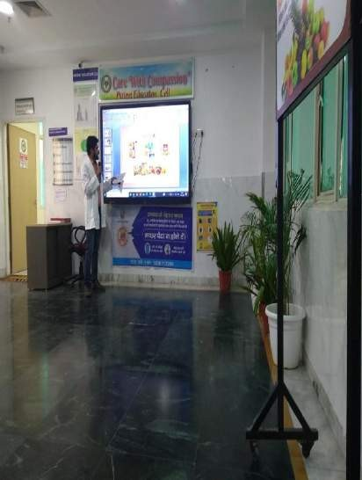
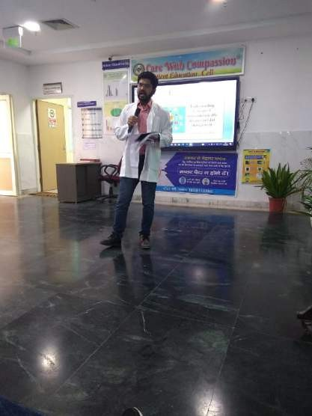

AWARENESS LECTURE

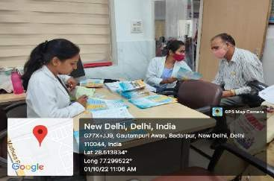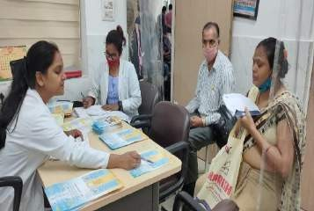
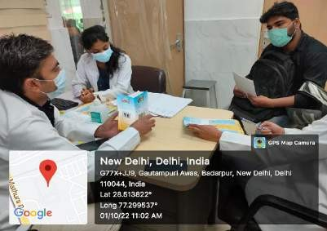
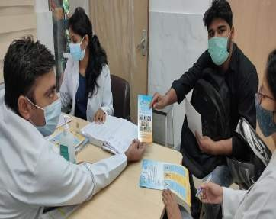

HEALTH check up CAMP

